Step #20: Define Phasors for fundamental waveform. Note we shifted the phase angles to assume generator voltage has an angle of zero.

$$\vec{V_{GenA(1)}}=56.67∠0$$

$$\vec{I_{GenA(1)}}=9.47∠20.4$$

$$\vec{V_{LoadA(1)}}=37.68∠155.61$$

$$\vec{I_{LoadA(1)}}=7.53∠155.61$$

Step #21: Complex Power

$$P_{GenA(1)}=56.67*9.47∠0+20.4=503+187.07j$$

$$P_{LoadA(1)}=37.68*7.53∠155.61-155.61=283.73$$

Step #22:

When comparing the power calculated in step #21 and #16, the results to do not match up. This is because we are only considering the first harmonic in #21. While #16 has the sum of all harmonics.

Step #23:

$$Delta V_{Load}=104.42-82.17=22.25V$$

$$Delta I_{Load}=20.88-16.43=4.45A$$

$$Real Power Load=99 Watts$$

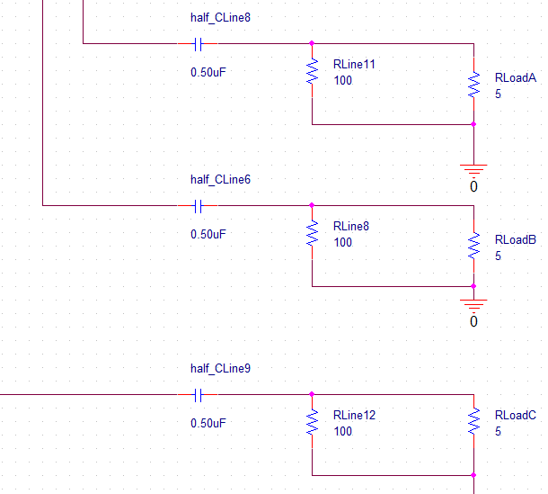

Figure 12: Filter Design for Load

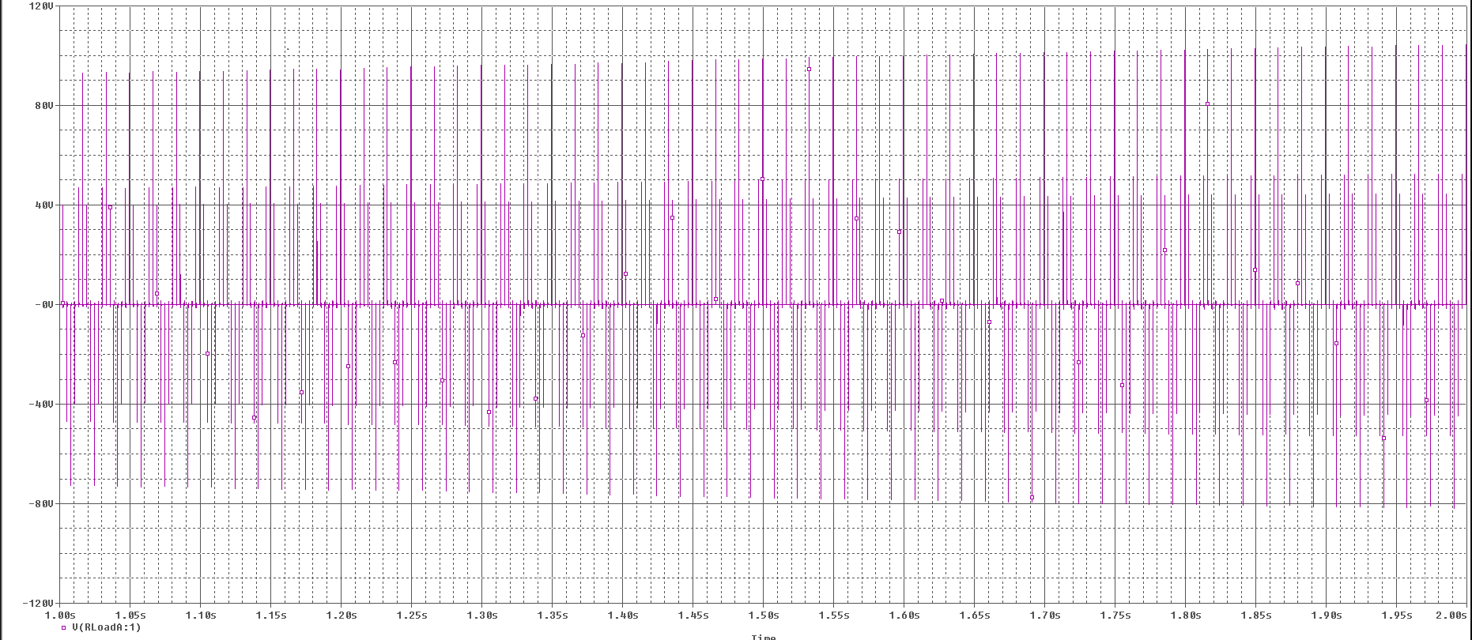

Figure 13: Load Voltages (A) vs. Time with Filter

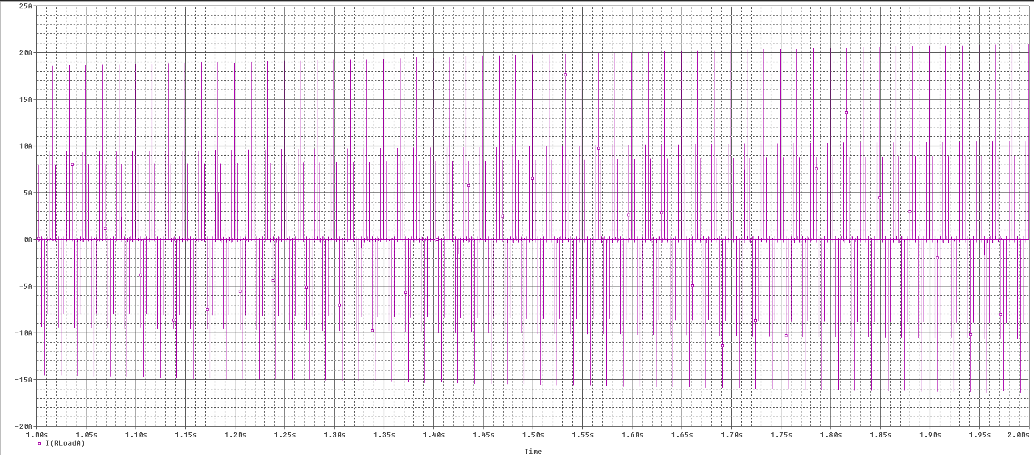

Figure 14: Load Current (A,) vs. Time with Filter